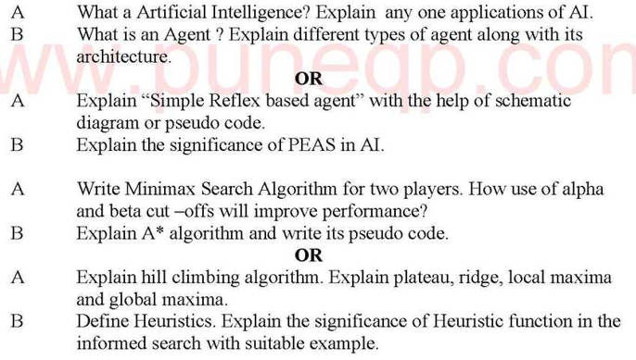
- Write PEAS representation for the taxi’s task environment, vacuumed cleaner environment
- .Discuss A* algorithm in detail
- . .Discuss AO* algorithm in detail
- Solve the water-jug problem by writing the production rules
- . Explain in detail the applications of Artificial Intelligenc
- Discuss categorization of intelligent systems
- Solve the following crypt arithmetic puzzle. Write constraint equations and find one solution using DFS by showing the steps involved in finding the solution. B A S E + B A L L ----------------- G A M E S
- Solve N-Queen problem ,graph coloring problem using CSP.
- . Briefly Explain types of Environments for Artificial Intelligence agents to perceive.
- Explain about hill climbing heuristic search technique.
- Discuss Simulated Annealing algorithm.
- .Discuss Beam search algorithm

